Name: ………………………………………. Class: ……………………………………..

Y10 RE KNOWLEDGE ORGANISER HOMEWORK SPRING AND SUMMER

Component 1: Religious, Philosophical, Moral and Ethical Studies in the Modern World
Page 2-4: Issues of Good and Evil
Page 5-7: Issues of Human Rights

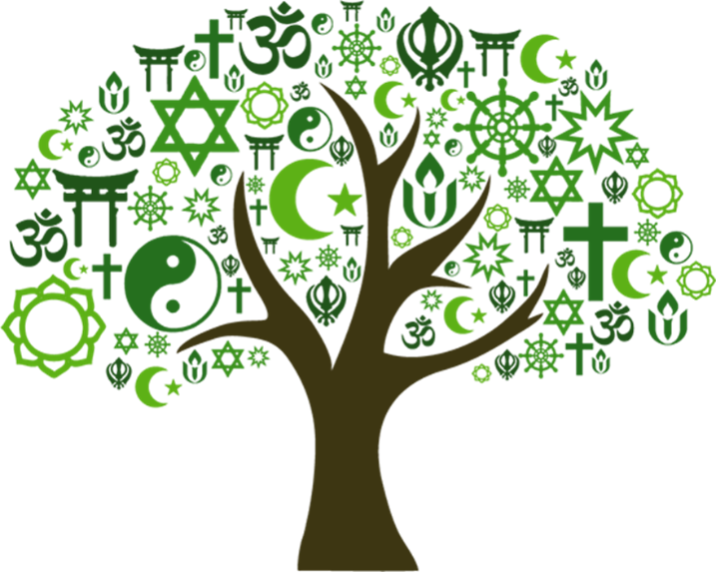

Theme 3- Issues of Good and Evil
G&E1 WHAT IS GOOD AND EVIL?

1. Relative morality= the rightness/wrongness of an action… | Depends on the situation
2. What do Quakers consider their conscience to be? | “small, still voice of God”
3. What is one of the 10 Commandments? | “Thou shall not kill”
4. What is the Muslim holy book? Absolute or relative? (it’s Allah’s exact words). | Qur’an- Absolute
5. Christians should show _______ love | agape
G&E2 THE PROBLEM OF EVIL

6. What is the problem of evil? | “If God is omnipotent, omnibenevolent and omniscient, why does suffering exist?” Epicurus
7. Stephen Fry- “God must be a _________” | Maniac” e.g. bone marrow cancer in children
8. What do some Christians believe we have all inherited? | Original sin
9. Irenaeus came up with the soul- __________ theodicy | Making- avoiding evil and helping others helps our souls become heaven worthy
10. State two facts about Job. | Livestock and children killed, struck down with disease- Job remained faithful to God
G&E3 CRIME AND PUNISHMENT

11. Give two causes of crime. | Social/financial/personal
12. What does retribution mean? | Revenge on behalf of victim e.g. fine for stealing
13. “Eye for….” | Eye, tooth for a tooth, life for a life”
14. What does deterrent mean? | To stop people committing crimes- “cut off the hand of the thief”
15. What is the reoffending rate in Norway? | 20%- focus on reform as aim of punishment
G&E4 TREATMENT OF PRISONERS

16. What do prison chaplains do? What aim of punishment could this link to? | Provide pastoral, religious care in prisons- reform, rehabilitation
17. Who was an example of a prison reformer? | Elizabeth Fry
18. Which religious group did she belong to? | Quakers
19. Islam quote: “Let harm be met by…” | Equal harm”- retribution/deterrent
20. Who was an example of a prison chaplain? | Lesley Nicholson/Kate Johnson
G&E5 CAPITAL PUNISHMENT

21. Which state has the highest death penalty rate? | Texas- Evangelical law makers
22. Why are most Christians against the death penalty (any reason?) | Jesus preached agape, forgiveness,  Innocent people murdered- 144 USA
23. “Protect the ___________” | Ummah
24. Apply “most-merciful” (99 names) to the death penalty. | Follow Allah’s example- not put people to death
25. “Love your enemies and pray….” | For those who persecute you”
G&E6 FORGIVENESS

26. “Blessed are the merciful for they shall be shown ___________” | Mercy
27. What were Jesus’ last words? | “Forgive them Father, for they know not what they do”
28. State two facts about Gee Walker. | Forgave son’s killers, followed Jesus’ example, wants them in prison
29. Who did Muhammad forgive? | Old woman who kicked dirt and threw rubbish at him
30. What is forgiveness? | Giving up feelings of resentment/desire for revenge
END OF THEME RECAP

31. Standards that determine right from wrong e.g. absolute | Morality
32. To make decisions freely | Free will
33. Actions that are beneficial and morally right | Good
34. Actions that are morally wrong e.g. murder | Evil
35. Deliberate wrong actions violating religious laws | Sin
36. Pain or distress caused by injury, illness or loss | Suffering
37. Where people are treated fairly and equally in society | Justice
38. Penalty given to someone for a crime or wrong they have done | Punishment
39. To give up the desire for revenge | Forgiveness

Theme 4- Issues of Human Rights

HR1 PERSONAL CONVICTION

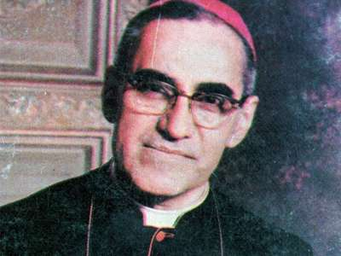  - Name and state 2 facts about this man. | Oscar Romero, born 1917- Archbishop in El Salvador in 1977, hosting radio shows and meetings criticising the government, assassinated in 1980.
- What was his personal conviction? | All human beings should be treated with government
- Jesus came to “release the ________” | Oppressed
- State two facts about Malala Yousafzai. | Born in northwest Pakistan, wrote a blog at 11 years old, shot by the Taliban on the way to school for campaigning for girls’ right to an education.
- What was her personal conviction? | Every girl should have the right to an education.
HR2 PREJUDICE AND DISCRIMINATION

- What is the difference between prejudice and discrimination? | Prejudice- pre-judging someone before you know them. Discrimination- acting on that prejudice, treating someone negatively.
- Arguably, how has the Catholic church discriminated against same-sex couples? | By not allowing them to be married within the Catholic church.
- What word means the fear or hatred of Muslims? | Islamophobia
- What Qur’anic quote suggests we should treat all humans equally? | “equal as the teeth of a comb” OR “made from the soil of many colours”
HR3 RACISM

- How did Martin Luther King Jr stand up against racism? | Led the 1955 Montgomery Bus Boycott.
- Give a Biblical quote that could have inspired him. | “we are all one in Christ” OR “pray for those who persecute you”
- What historical racist group claimed to be motivated by Christianity? | Ku Klux Klan
- State two facts about Malcolm X. | Originally part of Nation of Islam (violent approach), went on Hajj, changed opinion, assassinated by NoI.
- Qur’an- “Allah made Adam from the ______ of many ________” | Soil, colours
HR4 RELIGIOUS EXPRESSION

- What is evangelism? |  | Preaching with the intent to convert others
- One of our Human Rights is “Freedom of __________” (right to believe in what you want) |  | Religion
- “Go and preach the _________” |  | Gospel
- What type of clinics do some Christians protest outside of? |  | Abortion
- “Women should guard their _______” |  | Modesty
- How might the quote above link to religious expression? |  | Muslim women may choose to wear hijabs
- What is extremism? Give an example. |  | The murder of George Tiller by an anti-abortion protester
HR5 CENSORSHIP

- “Bad company corrupts ______ _______” |  | Good character
- Explain the quote above. |  | Good people can be led to sin by bad people
- Why do Muslims censor images of Allah? |  | As it is shirk (to worship anything other than Allah)
- What country arguably censors religious expression e.g. no headscarves/hijabs? |  | France
HR6 WEALTH/CHARITY

- “Love of money is the….” |  | Root of all evil”
- What is tithing? |  | A voluntary 10% of your money to charity
- State two things Christian Aid do. |  | Help refugees, provide essential resources e.g. food
- What is Zakat and Sadaqah? |  | Zakat- compulsory 2.5% donation, Sadaqah- extra voluntary donation
- What is riba? |  | Forbidden practice of making money off a loan
END OF THEME RECAP

- Stopping something offensive being said or worn. |  | Censorship
- Prejudging people without good reason. |  | Prejudice
- Treating people differently based on prejudice. |  | Discrimination
- Believing in ideas that are very different from what most believe e.g. ISIS. |  | Extremism
- Rights that all humans have e.g. right to free speech |  | Human Rights
- Something a person believes strongly in e.g. Malala education |  | Personal Conviction
- Being poor compared to others in a country |  | Relative poverty
- Being so poor that basic needs aren’t met e.g. food |  | Absolute poverty
- Ensuring everybody has equal rights e.g. MLK |  | Social Justice

